Website

General:
- When you start scrolling up, make the header re-appear instead of having to scroll to the top to access it.
- There are no animations on ‘Our Services’ and ‘Pricing’

Homepage:
- The embedded video should play automatically, the user shouldn’t be able to pause/play.
- FAQ section at the bottom, none of the questions have answers, please find the answers below…
A1. Our assistants at JuggleJoy can help you with those fussy everyday tasks that take lots of time out of your daily schedule. Delegate booking medical appointments, party planning, holiday arrangements and home maintenance tasks effortlessly with our easy-to-use platform. This gives you more time to spend with family while your to-do list gets done and dusted!

A2, Delegating a task is simple. Log in to your JuggleJoy account, navigate to the task delegation section, and provide details such as the task description, deadline, and any specific preferences. Our assistants will take it from there, keeping you in the loop with real-time updates on how each task is progressing.

A3, We like to keep things simple, which is why we have a subscription-based model with a single-price plan of £126/mo. No hidden fees or additional charges - guaranteed.

A4, Whether you have just a couple of things on your to-do list or a chore mountain to climb, you can delegate as many tasks as you want with JuggleJoy. We have flexibility with our subscription model to meet your family's unique needs and schedule. We also understand the need for recurring tasks, and you can easily allow our assistants to manage ongoing responsibilities for your family.

A5, You can set deadlines when you delegate a task via your JuggleJoy account, but you will need to give a notice period of 36 hours before you want the task to start.

- The ‘Notify Me’ buttons should change colours when highlighted (similar to the Login button) - Done

Registration:
- Remove the word “Optional” from the Mobile No box, this option isn’t optional as the number will be used for 2FA. Following on, add * to represent it’s not optional. - Done
- ? icons are not correctly aligned within the box.- Done
- Also, please see the list of explainers for each box once the user clicks on the ? icon;
  - Mobile no: Please take a moment to verify your number. This helps us confirm your identity and secure your account.
  - Post Code: Your home address details are collected to assist with future tasks that may require this information.
  - Partner’s Email address: Enter your partner's email address in this field. We'll send them a special link via email to link your accounts together, enabling both of you to manage household tasks as one.

- Remove the box “tick if you are happy to be contacted by your assistant” under Mobile No, the mobile number will only be used for 2fa.
- Here is the registration page with 2fa incorporated below:
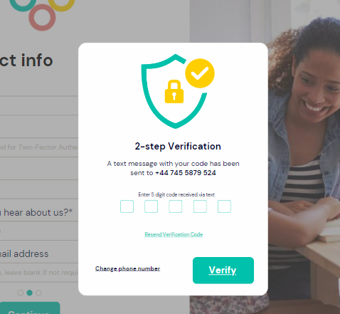
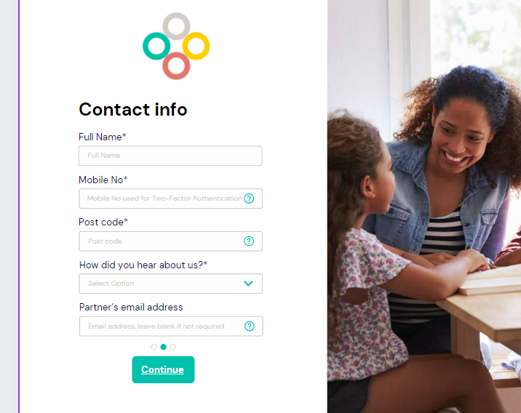

FAQ:
- Whenever I go between the topics on the left (i.e. Benefits, Pricing, etc.), the page refreshes and scrolls down. The whole page shouldn’t have to be refreshed from one topic to another.- Done
- The question ‘Can I delegate any tasks?’ within the Task Delegation doesn't show an answer, even though there is an answer provided in the admin portal.- Done

Pricing:
- Can we change the prices within the admin portal in the future?

Blog
- The title & layout of the blogs within each of the categories don’t look the same as the Blog homepages.
- Font size should be set to 18, there is currently no way I can change it (which is fine as long as we can default to 18).
- How can I add an image within the blog?
- The green line within a blog is meant to be a progress bar, it’s currently static, and should be the same as below….

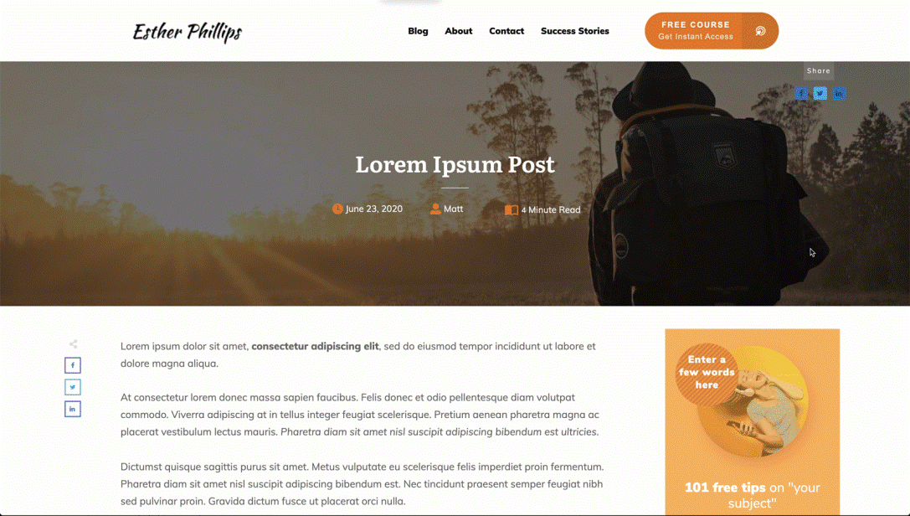

- Currently, a blog is taking up the whole width of the screen. On average (at font size 18) it should be around 12-14 words per line with plenty of white spaces on either side. Use this page as an example of layout https://medium.com/corporateunderbelly/the-untold-story-behind-the-key-bridge-collapse-in-baltimore-b29c99d419dd
- Remove the comment icon 🗩 at the top and bottom of a blog, no one needs to comment.

Send a gift
- The percentages are not set correctly. 1st, 5% off £119. 2nd, 10% off £340. 3rd, 15% off 643. 4th, 20% off £ 1,210
- The Buy button is misplaced
User Portal

- After the greeting ‘Good Afternoon’ at the top of the page, it should only display the user’s first name, not full name.
- The introductory text at the top of the Draft tab needs to be revised to reflect the information provided below:
“This is your private space to list all the tasks weighing your mind. Please note that your assistant cannot access the tasks listed here. When you're ready to delegate a task, provide further details for each task and click 'Create Task'. ”- Done

- Pending tab: change the introductory text to:
“Your assistants will prioritise these pending tasks based on the deadlines you set. Sit back, relax, and enjoy seeing your to-do list shrink!”- Done

- Completed tab: Redo the introductory to:
“Here, you'll find all previous tasks were completed or cancelled. Use this section to review your archived tasks.”- Done

- When the mouse highlights one of the tabs (Draft, Pending, …) or one of the filters, the colour should change to the same colour as the current active tab.
- Make the whole task box clickable, instead of just clicking on the arrow to open the task.
- We need to ensure the assistants' full names aren’t revealed to the end user. So it should just be a first-name basis.- Done
- Within a task page, the “Edit task” button disappears, when you click on the View min-task, attachment, and Task Events tabs.
- Rename the following tabs: ‘Message Handler’ to ‘Chat’. ‘Task Events’ to ‘Events’. ‘View mini-tasks’ to ‘Mini-tasks’. (this shouldn't just be changed on the mobile portal but on the desktop version too.

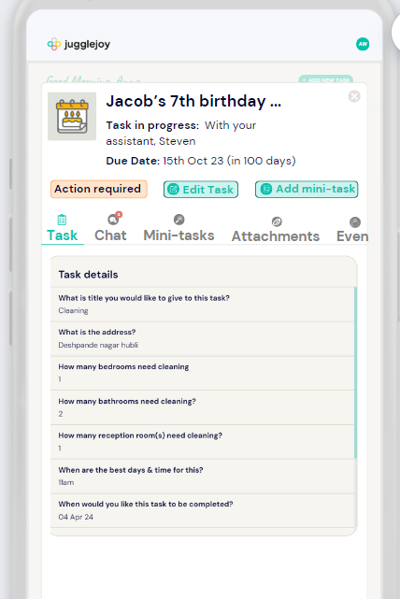

Mobile version
General:

- When starting to scroll up the header should appear at the top instead of having to scroll to the top to be accessed, and it can then disappear if you start scrolling down again.
- The hamburger menu icon should be like below
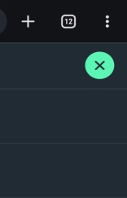
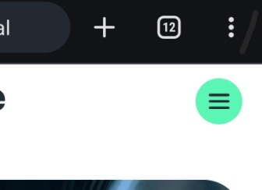

When not active When active

- Assistant and Handler logins shouldn’t appear on the main site, maybe you can provide me with the link, which we can share internally. - Done

Registration:
- There are too many white spaces, and the picture on the right stretches too long. Move the picture to the bottom of the page, similar to the login page.

Login:
- It works better than the above, however, the login details should be what users see first, so the picture is at the bottom and login details at the top.

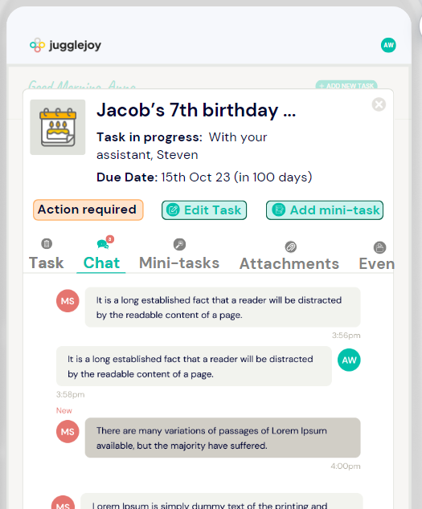

User Portal: amend the mobile version of the ticket window to below . . .

